Issue Summary

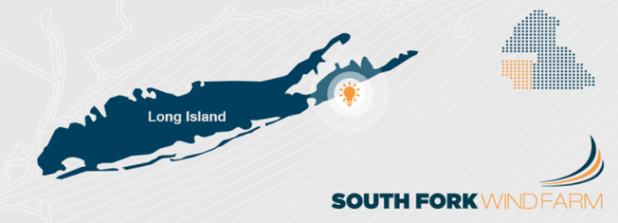
Development is advancing on the 90-MW Deepwater Wind (DWW) off-shore wind project to the east of Montauk Point on the South Fork of Long Island (LI), but a key decision – where to bring the project’s output ashore – is yet to be finalized. Two options under consideration have significant implications in terms of cost and ratepayer benefits, reliability, resilience, aesthetic impacts, environmental and community impacts, the ability of communities in the South Fork to determine their local development and environmental policies, as well as the freedom of consumers to exercise choice over their source of electricity supply. Despite the far-reaching implications of this decision, these alternatives have not yet been evaluated in a transparent and open manner, although some considerations have emerged in the context of review of the Long Island Power Authority’s (LIPA) Integrated Resource Plan (IRP).

The interconnection option favored by the LIPA and PSEG Long Island (PSEG), entails tying the off-shore facility into the Long Island Loop of the New York Grid near Riverhead (see Option 1 in Figure 1), at the western end of the Peconic Bay, which separates the North and South Forks of LI. An alternative connection point involves bringing the cable from DWW ashore at Amagansett, on the South Fork (see Option 2 in Figure 1). Both options will require infrastructure improvements to accommodate the output from DWW: the first requires upgrades to transmission and distribution lines between Riverhead and the South Fork, while the second will require upgrades within the South Fork network. The South Fork communities of East Hampton and Southampton have both enacted community renewable energy (RE) goals (100% by 2020 and 2025, respectively), and contemplate making the development of distributed RE resources and storage a central part of the achievement of those objectives, together with power from DWW. However, the feasibility of the community policies is influenced by the location of the DWW feeder line connection onshore and the cost of the options, which will have implications for ratepayers.

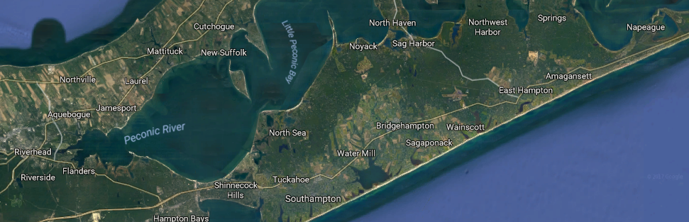
Option 1
Option 2
Figure 1: Interconnection options for the South Fork Windfarm

Current Situation

The South Fork Load Pocket (LP) ranges between 75 MW and 275 MW between the winter and summer months. Peak loads are expected to reach 300 MW sometime in the 2020 to 2022 time frame. As a radial extension of the LI Grid beginning at the LI Loop to the west of the Shinnecock Canal (with maximum transfer capacity of 290 MW), the South Fork LP requires operation of local generation resources for loads in excess of 182 MW to ensure quality of service (92 MW of aging thermal capacity has been in place dating back to the 1960s).

In 2015 PSEG issued a tender to solicit 21 MW of clean energy resources to manage peak load requirements on the South Fork. As part of its program of generation expansion, LIPA has also approved DWW’s South Fork Wind Project with a capacity of 90 MW, which could represent a significant contribution of additional capacity for the South Fork if the feeder line ties into the grid at Amagansett (Option 2). (In addition, the capacity may be increased if a DWW expansion is accepted and approved by LIPA and PSEG.)

The South Fork communities believe that if DWW were integrated in the South Fork LP together with upgrades, including distributed resources and smart grid technologies, the region could achieve their RE policy goals with capacity to spare. East Hampton estimates that 50% to 70% of its potential capacity utilized from behind-the-meter solar, storage, local wind generation, geothermal, local demand response and energy efficiency through local Energy Co-ops and Decentralized Service Organizations, would make it a net exporter of RE, after fulfilling its 100% renewable electricity policy.

On the other hand, if DWW’s output were to be connected to the Long Island Loop west of Riverhead (Option 1) with upgrades facilitating transmission to the South Fork Load Pocket, this would contribute much less RE to the South Fork LP, with balancing power coming from thermal facilities located in the central part of LI. Some estimates suggest the RE contribution might be just 3% RE to the East Hampton electrical system, along with over 95% or more fossil fuel-based energy (using Renewable Energy Long Island’s assumptions regarding low penetration of behind the meter solar and battery systems).

The system upgrades required for the connection of DWW to the LI Loop near Riverhead are estimated at over $500 million, and would be recovered by PSEG LI from the ratepayer base. In contrast, the South Fork communities estimate that between $200 to $400 million of private sector funds could be invested in a distributed collectively intelligent grid on the South Fork, including significant distributed energy resources (DERs) making it possible for local production of RE and the DWW offshore resource to support over 100% of the South Fork LP’s requirements. This approach would be consistent with the State’s “Reforming the Energy Vision”, would be aligned with their local government policies and would make a substantial contribution to local business growth and new local green jobs.

Given this, many of the East Hampton and Southampton Energy Sustainability Committee members do not see a technical justification for LIPA/PSEG to invest over $500 million for transmission lines to East Hampton via Riverhead that would be paid for by ratepayers. Furthermore, members are concerned that this investment would instead serve the interests of PSEG as part of its larger corporate strategy to integrate thermal resources based in New Jersey (connected to the LIPA system by the Neptune submarine cable) and allow it to position itself to compete for rights to other offshore wind blocks on the continental shelf south of Long Island.

PSEG’s Long-Range Plan (“Utility 2.0”), July 1 2014, pages 3-29.

